‘OOPs’
Name: ISHAQKHAN
Sap Id: 73423
Course: Object Oriented Programming t
Teacher: Prof. Muhammad Imran
Note:
I’m submiting it late because my moellim was blocked
https://github.com/ISHAQKHAN196/OOP-2nd-Semester-Lab-Task

TASK:01
A BANK WANTS A SYSTEM THAT:
• STORES CUSTOMER INFORMATION
• MANAGES BANK ACCOUNT OPERATIONS
• ALLOWS DEPOSIT, WITHDRAWAL, AND BALANCE CHECKING
WE WILL USE TWO CLASSES:
1. CUSTOMER
2. BANK ACCOUNt

MainClass:

public class Main1 {
public static void main(String[] args) {
Customer c1 = new Customer();
c1.name = "ISHAQ-KHAN";
c1.customerId = 73423;// ISHAQKHAN-73423
BankAccount acc1 = new BankAccount();
acc1.accountNumber = 76585;
acc1.balance = 999999999;
acc1.customer = c1;// ISHAQKHAN-73423
acc1.displayAccount();
acc1.deposit();
acc1.withdraw();
acc1.displayAccount();
}
}

Class customer:

public class Customer {// ISHAQKHAN-73423
String name;
int customerId;
void displayCustomer() {
System.out.println("Customer Name: " + name);
System.out.println("Customer ID: " + customerId);
}// ISHAQKHAN-73423
}

Class BankAccount

public class BankAccount {
int accountNumber;
double balance;// ISHAQKHAN-73423
Customer customer; // ISHAQKHAN-73423
void deposit() {
balance = balance + (double) 29999;
System.out.println("Deposited: " + (double) 29999);// ISHAQKHAN-73423
}
void withdraw() {
if ((double) 30000 <= balance) {// ISHAQKHAN-73423
balance = balance - (double) 30000;
System.out.println("Withdrawn: " + (double) 30000);// ISHAQKHAN-73423
} else {
System.out.println("Insufficient Balance!");
}
}
void displayAccount() {
customer.displayCustomer();
System.out.println("Account Number: " + accountNumber);
System.out.println("Current Balance: " + balance);
}
}

output:

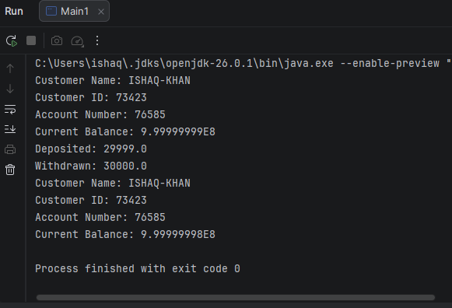

TASK:02;
Prime numbers in java

Code:

void main() {
Scanner s = new Scanner(System.in);
IO.println("Enter Number:");
int n;
int count = 0;
n = s.nextInt();
for (int i = 1; i < n; i++) {
if (n % i == 0)
count++;
}
if (count == 2)
IO.println(n + " Is A Prime Number");
else
IO.println(n + " Is Not A Prime Number");
}

output:
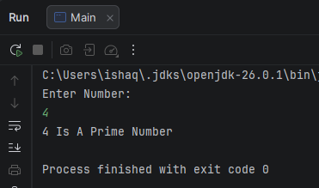

TASK:03;
Find length of Array;

public class Main {

public static void main(String[] args){
int[] a ={1,2,8,6,9,10};
int length;
length=a.length;
System.out.println("Length Of Array Is:"+length);
}
}

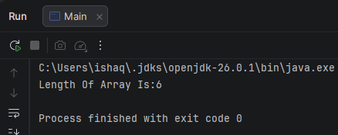
Output

TASK:04;
Find the number is palindrome or not

import java.util.Scanner;
// ISHAQKHAN-73423// ISHAQKHAN-73423// ISHAQKHAN-73423
public class Main {
public static void main(String[] args){// ISHAQKHAN-73423
Scanner s=new Scanner(System.in);
int num,temp,r=0;
System.out.println("Enter Number:");
num=s.nextInt();
temp=num;// ISHAQKHAN-73423
while(num>0){
r=r*10+(num%10);
num/=10;
}// ISHAQKHAN-73423
if(temp==r)
System.out.println(temp+" Is Palindrome");// ISHAQKHAN-73423
else
System.out.println(temp+" Is Not Palindrome");
}
}

OUTPUT;
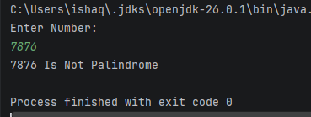

TASK:05;
Find the factorial number through Function;

import java.util.Scanner;
// ISHAQKHAN-73423
public class Main {// ISHAQKHAN-73423
static void fact(){
Scanner s=new Scanner(System.in);// ISHAQKHAN-73423
int a;
System.out.println("Enter Number For Factorial:");
a=s.nextInt();// ISHAQKHAN-73423
int fact=1;
for(int i=1;i<=a;i++)// ISHAQKHAN-73423
fact*=i;// ISHAQKHAN-73423
System.out.println("Factorial Of "+a+" Is = "+fact);
}
public static void main(String[] args){
fact();
}// ISHAQKHAN-73423
}

Output
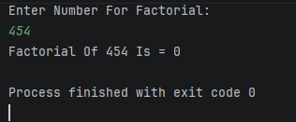

TASK:06;
Swapping numbers using tow variables

import java.util.Scanner;
// ISHAQKHAN-73423
public class Main {
public static void main(String[] args){// ISHAQKHAN-73423
Scanner s=new Scanner(System.in);// ISHAQKHAN-73423
int a,b;// ISHAQKHAN-73423
System.out.println("Enter Values For Swap:");
a=s.nextInt();
b=s.nextInt();// ISHAQKHAN-73423
a=a+b;
b=a-b;
a=a-b;// ISHAQKHAN-73423
System.out.println("Values After Swap Are:");
System.out.println("a= "+a);// ISHAQKHAN-73423
System.out.println("b= "+b);
}
}

Output;
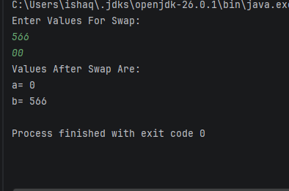

TASK:07;
Swap values using third variable

import java.util.Scanner;// ISHAQKHAN-73423
public class Main {
public static void main(String[] args){
Scanner s=new Scanner(System.in);
int a , b, temp;// ISHAQKHAN-73423
System.out.println("Enter Values For Swap:");
a=s.nextInt();// ISHAQKHAN-73423
b=s.nextInt();
temp=a;// ISHAQKHAN-73423
a=b;// ISHAQKHAN-73423
b=temp;// ISHAQKHAN-73423
System.out.println("Values After Swap Are:");
System.out.println("a= "+a);
System.out.println("b= "+b);
}
}

Output;
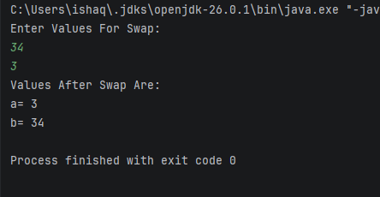

TASK:08
Right angle triangle using nested loop

public class Main {
// ISHAQKHAN-73423
public static void main(String[] args) {
for (int i = 1; i <= 5; i++) {// ISHAQKHAN-73423
for (int j = 1; j <= i; j++) {// ISHAQKHAN-73423
System.out.print("*");
}
System.out.println();// ISHAQKHAN-73423
}
// ISHAQKHAN-73423
}
}

Output;
